**MainScreen-1 Layout**

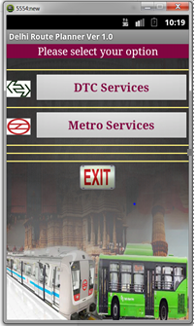

## Fig 1: Home page: the main screen of the app. This is called the splash activity which opens up as soon as the app starts up. Before the main activity is displayed or loaded an animation of the logo icon placed in the center of the screen is shown after which the main screen is loaded and options are given for the user to select from among the two options namely for DTC services and Metro Services .After the options are selected their respective screens are displayed .